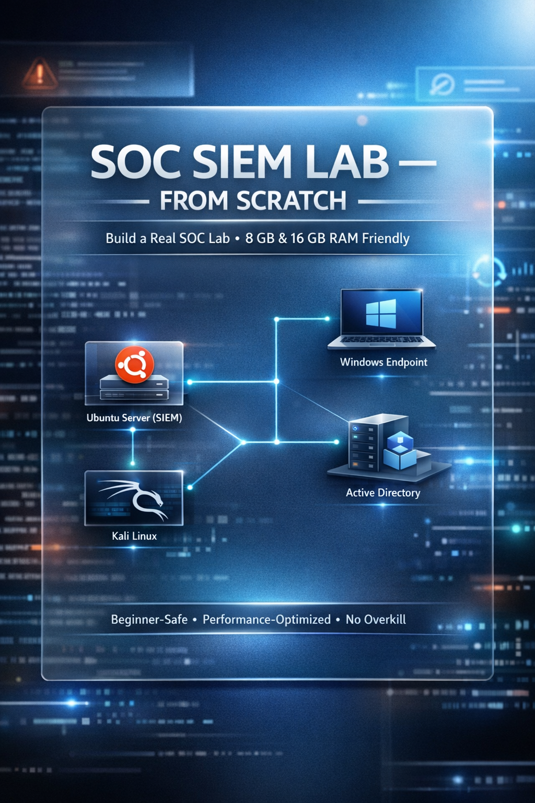

🚀 SOC SIEM LAB — FROM SCRATCH

🔑 Core Rule (Read Once)
Do NOT install everything at once.
Install only what is needed for the current phase.

STEP 0️⃣ — HOST PREP (WINDOWS 11)

✅ Check hardware (minimum)
- RAM: 16 GB RAM: RAM: 16 GB recommended (8 GB supported in constrained mode — see below)
- Disk: 150–200 GB free
- Virtualization: Enabled in BIOS

✅ Install hypervisor
- VirtualBox (recommended)
OR
- VMware Workstation
👉 Use ONE only, not both.

STEP 1️⃣ — DOWNLOAD REQUIRED ISOs (ONLY THESE)
Do not install yet. Just download.

Linux
- Ubuntu Server LTS (no GUI)
→ This will run Splunk
- Kali Linux Installer ISO
→ Attacker (used only in Phase 1)

Windows
- Windows 10 (ISO)
→ Endpoint user machine
- Windows Server 2019 (ISO)
→ Domain Controller (AD)
⚠️ Do not download Windows Server 2022 yet.
2019 is lighter and perfect for labs.

STEP 2️⃣ — INSTALL ORDER (THIS IS CRITICAL)

❌ Wrong approach
“Install all VMs first”

✅ Correct approach
We install one phase at a time.

🧱 PHASE 1 — LINUX + SIEM FOUNDATION

🎯 Goal
- Learn Splunk basics
- Learn Linux log ingestion
- Keep RAM usage low

🖥️ INSTALL ONLY THESE VMs

1️⃣ Ubuntu Server (FIRST VM)
Purpose: Splunk SIEM + Linux logs
VM settings
- RAM: 4 GB
- CPU: 2 cores
- Disk: 50 GB
- Network: NAT + Host-only
Install notes
- No GUI
- Create a normal user
- Enable SSH
👉 After install, STOP.
Do NOT install Windows yet.

2️⃣ Kali Linux (SECOND VM)
Purpose: Attacker (temporary)
VM settings
- RAM: 2 GB
- CPU: 1–2 cores
- Disk: 30 GB
👉 After install, STOP.

✅ PHASE 1 RUNNING MACHINES
- Ubuntu Server
- Kali Linux

❌ SHUT DOWN
- Everything else (not installed yet)

🧱 PHASE 2 — WINDOWS ENDPOINT (NO AD YET)
⚠️ Do this only after Phase 1 is understood.

🎯 Goal
- Windows logs
- Sysmon
- Endpoint detections

🖥️ INSTALL NEXT

3️⃣ Windows 10
Purpose: Endpoint user activity
VM settings
- RAM: 3 GB
- CPU: 2 cores
- Disk: 50 GB
After install
- Disable animations
- Disable OneDrive
- Install Sysmon (later)
- Install Splunk Forwarder (later)
👉 Kali is OFF during this phase.

🧱 PHASE 3 — ACTIVE DIRECTORY (FINAL CORE)
⚠️ This is where many people break their labs.
We do minimal AD only.

🎯 Goal
- Domain authentication logs
- Identity-based detections

🖥️ INSTALL LAST

4️⃣ Windows Server 2019
Purpose: Domain Controller
VM settings
- RAM: 4 GB
- CPU: 2 cores
- Disk: 50 GB
Install only
- AD DS role
- One domain
- One admin account
❌ No extra roles
❌ No second DC

STEP 3️⃣ — WHAT RUNS TOGETHER (VERY IMPORTANT)
Phase | Running VMs | RAM Used
Phase 1 | Ubuntu + Kali | ~6 GB
Phase 2 | Ubuntu + Win10 | ~7–8 GB
Phase 3 | Ubuntu + WinServer + Win10 | ~11 GB
👉 Never run all 4 together.

STEP 4️⃣ — NETWORKING (KEEP IT SIMPLE)
Use:
NAT + Host-only (bridged only if you know why)
Why:
- Internet access
- Internal lab communication
- Stable IPs
Ensure:
- All VMs can reach Ubuntu (Splunk)
- Windows 11 host can access Splunk UI

STEP 5️⃣ — WHEN TO INSTALL SPLUNK (IMPORTANT)
❌ Not during OS install
❌ Not on multiple machines
✅ Install Splunk only after Ubuntu Server is stable
Splunk runs on:
- Ubuntu Server (CLI only)
- UI accessed from Windows 11 browser

STEP 6️⃣ — COMMON BEGINNER MISTAKES (AVOID)
❌ Installing AD first
❌ Installing GUI on Ubuntu
❌ Giving 6–8 GB RAM to every VM
❌ Running Kali all the time
❌ Installing Splunk everywhere
This kills performance and learning.

🧪 SOC SIEM LAB — 8 GB RAM CONSTRAINED SETUP
⚠️ Read carefully.
With 8 GB RAM, this lab works only if you respect limits.
Ignore them, and your system will crawl or crash.

🔑 HARD RULES (NON-NEGOTIABLE)
• Max 2 VMs running at any time
• Host Windows 11 must stay under 3 GB usage
• Kali is temporary only
• AD is short-session only, not daily use
If you want comfort → upgrade to 16 GB.
If not → follow this exactly.

🧱 PHASE 1 — LINUX + SIEM (8 GB MODE)

✅ Running VMs (ONLY THESE)
• Ubuntu Server
• Kali Linux (temporary)

🖥️ VM SETTINGS (STRICT)
Ubuntu Server (Splunk)
• RAM: 3 GB
• CPU: 2 cores
• Disk: 50 GB
• No GUI
• SSH enabled
Kali Linux
• RAM: 1.5–2 GB
• CPU: 1 core
• Disk: 30 GB
👉 Total VM RAM ≈ 5–5.5 GB
👉 Remaining for host ≈ 2.5–3 GB

❌ MUST DO
• Shut down Kali immediately after attacks
• Run Splunk searches patiently (no multitasking)

🧱 PHASE 2 — WINDOWS ENDPOINT (8 GB MODE)

✅ Running VMs
• Ubuntu Server
• Windows 10

🖥️ VM SETTINGS
Windows 10
• RAM: 2.5–3 GB
• CPU: 2 cores
• Disk: 50 GB

REQUIRED OPTIMIZATION (MANDATORY)
After Windows install:
• Disable animations
• Disable OneDrive
• Disable background apps
• Do NOT install unnecessary tools
👉 Kali MUST be OFF in this phase.

🧱 PHASE 3 — ACTIVE DIRECTORY (LIMITED USE)
⚠️ This phase is the danger zone on 8 GB.

✅ Running VMs (SHORT SESSIONS ONLY)
• Ubuntu Server
• Windows Server 2019
• Windows 10

🖥️ VM SETTINGS
Windows Server 2019
• RAM: 3 GB
• CPU: 2 cores
• Disk: 50 GB

AD CONSTRAINT RULES
• Single domain
• Single user
• AD DS role only
• Session length: 30–60 minutes max
❌ Do NOT:
• Leave AD running idle
• Add extra roles
• Run Kali during AD sessions
👉 Total VM RAM ≈ 8.5–9 GB
⚠️ This exceeds physical RAM — works only via OS memory compression.

📊 SAFE RUN MATRIX (8 GB)
Phase | Allowed Running VMs | Safe
Phase 1 | Ubuntu + Kali | ✅
Phase 2 | Ubuntu + Win10 | ✅
Phase 3 | Ubuntu + Win10 + WinServer | ⚠️ Short only
Any | All 4 together | ❌ NEVER

✅ FINAL VERDICT
• 8 GB → Valid for fundamentals, discipline required
• 16 GB → Proper SOC lab experience

